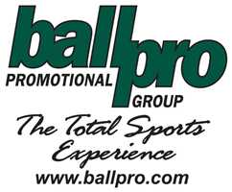
PRODUCT SAFTEY POSITION STATEMENT
Ball Pro has initiated best practice procedures regarding product safety and regulatory compliance within our promotional products industry. Ball Pro has put in place a comprehensive safety program for their entire product line with emphasis on Children’s Product Safety. Ball Pro has established a Compliance and Safety Committee which includes our Vendor Relations Manager, Marketing Manager, and Purchasing Manager.
Our committee continuously works with our manufactures to promote and improve the safety of our products. We have compiled a list of children’s products and are continuously obtaining accredited 3rd party test reports from our manufactures to certify these products meet federal guidelines. General Certification of conformity reports are available.
Ball Pro has a plan to have all test reports posted on ballpro.com by 2013.

